How to Deal With Staff Who Can’t or Won’t Perform
By Alex. Brogan

Online Resource Pack Contents
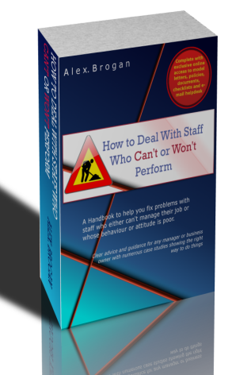
Template Policies:
Capability Policy
If you adopt this policy it can then be utilised when a member of staff persistently fails to carry out their responsibilities or duties in a satisfactory manner either due to a lack of ability or knowledge, inadequate training or lack of experience.
Attendance Policy
This policy, if adopted, will enable the company to address absence issues, both short-term persistent absences and long-term sickness or disability, in a fair, consistent and equitable manner.
Disciplinary Policy
This policy enables management to deal effectively with those employees who won't comply with the company's standards of conduct and performance in the workplace.
Stage 2- Informal Approach - Documents
Informal meeting request letter / email
Use this to invite an employee to an informal meeting to discuss their performance

Informal meeting checklist
Use this checklist to ensure you have prepared everything properly for your informal meeting

Grey area checklist
When you are trying to ascertain why an employee has a performance problem, but cant quite pin this down, work through this checklist

Performance action plan template (use for competence and short-term persistent absence cases)
Immediately following the informal meeting, complete this template which outlines the performance problem, the actions agreed for the employee and the company, and the timescales for improvement. The employee should receive a copy, and a copy should be placed on their personal file. It should be reviewed regularly with the employee.

Performance action plan template (use for long-term illness / disability cases)
The purpose of this Plan is to record the problem, medical prognosis (if appropriate), and the actions and reasonable adjustments that have been agreed in order to support the member of staff in returning to work within a reasonable timescale. The employee should receive a copy, and a copy should be placed on their personal file. It should be reviewed regularly with the employee.

Stage 3 -Formal Approach – Documents

Capability - Health Long-Term Illness / Disability

Letter inviting to formal meeting – long term illness / disability
Use this letter template to invite an employee to a formal meeting to discuss their long-term sickness absence.

Letter setting up a formal capability hearing
Use this template letter to invite an employee to a formal capability hearing.

Termination letter – long-term illness / disability
Use this template letter to terminate an employee on capability (health) grounds following a capability hearing.

Capability - Health Short-term Persistent Sickness

Letter inviting to formal meeting – short term sick
Use this template letter to invite an employee to a formal meeting to discuss their persistent short-term sickness absences.

Termination letter – persistent short term sickness absences
Use this template letter to terminate an employee on capability (health) grounds following a capability hearing.

Capability - Competence

Redeployment letter
Use this template letter following a formal capability hearing to offer the member of staff redeployment to a more suitable role with commensurate terms and conditions.

Termination letter - Capability - competence
Use this template letter following a formal capability hearing to terminate the employee on capability (competence) grounds.

Conduct

Suspension letter
Use to write to an employee confirming their suspension from duty.

Letter ending suspension
Use to inform an employee that their period of suspension is ended and that they should return to work

Carrying out an investigation checklist
Use this comprehensive checklist if you are tasked with carrying out an disciplinary investigation.

Witness statement template
Use this template to record witness statements.

Investigation report template
Use this report template for the outcome of the disciplinary investigation to conclude whether the case should proceed to a disciplinary hearing.

Notification of disciplinary hearing
Use this template letter to invite the employee to a disciplinary hearing.

No further action required letter
Use this template letter to the employee following a disciplinary hearing confirming that no further action will be taken.

First written warning
Use this template letter to the employee following a disciplinary hearing confirming a first written warning.

Final written warning
Use this template letter to the employee following a disciplinary hearing confirming a final written warning.

Letter of dismissal (with notice)
Use this template letter to the employee following a disciplinary hearing confirming their dismissal and detailing their notice entitlements.

Letter of summary dismissal
Use this template letter to the employee following a disciplinary hearing confirming their immediate summary dismissal without notice.

Stage 4 - Running an Appeal Process - Documents

Letter confirming appeal
Use this template letter to the employee confirming their appeal arrangements

Appeal form template
Form for the employee to complete which outlines the grounds of their appeal.

Letter with appeal outcome
Use this template letter to the employee outlining the outcome of their appeal hearing.

If you would like to access the online resource pack you can get details of how to purchase the ebook here: http://www.human-resource-solutions.co.uk/HR-Policy-Pages/Ebook/ebook-main-page.html

